Khmer Angkor Keyboard

Contents

Overview 2

Khmer Angkor Keyboard Layouts 2

Desktop –Windows/macOS 2

Touch –Android/iOS 3

Khmer Character Categories and Their Keystroke 4

Consonants 4

Dependent Vowels 5

Independent Vowels 5

Diacritics 5

Native Punctuations 6

Latin Punctuations 6

Currencies 6

Khmer Numerals 6

Divination Lore 6

Khmer Lunar Dates 7

Deprecated characters 7

Typing in Khmer 8

Joiners and Spaces 8

Constraints 8

Reorder 8

Rotation 8

# Overview

This documentation is adapted from two sources: ‘How to Type Khmer Unicode’ and ‘the Unicode Standard, Version 10.0.0’. Customizations have been made by the Keyman team.

# Khmer Angkor Keyboard Layouts

## Desktop –Windows/macOS

SHIFT key off

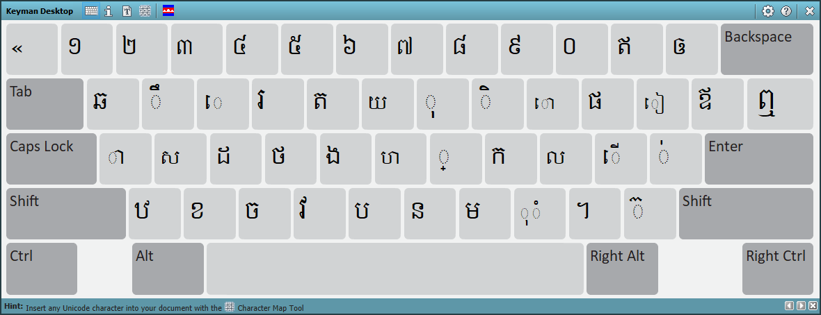

SHIFT key on

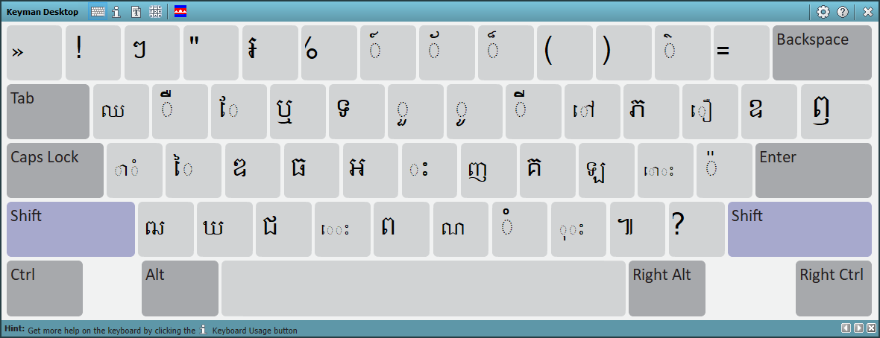

Right ALT key on (now Ctrl Alt)

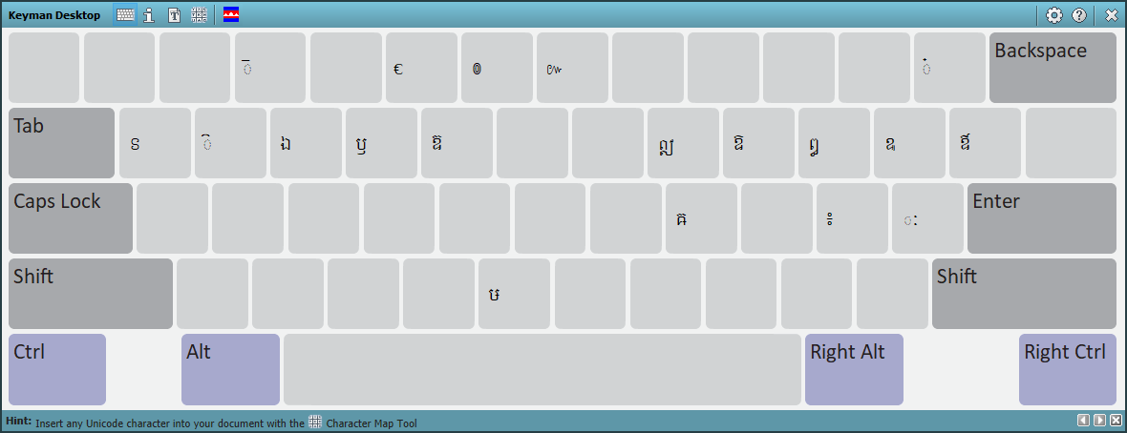

Ctrl Alt Shift key on

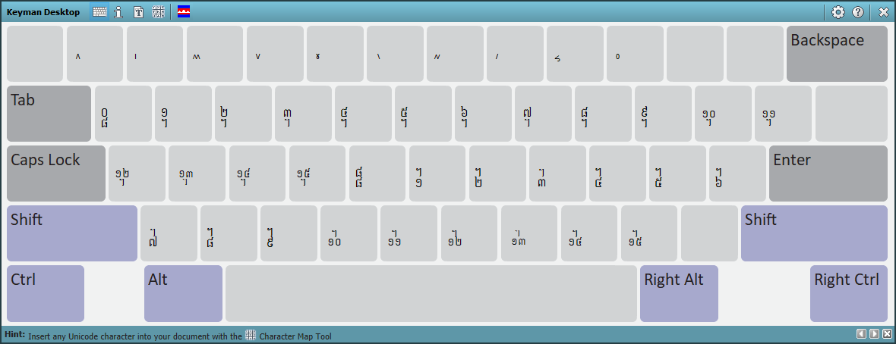

## Touch –Android/iOS

Default layout

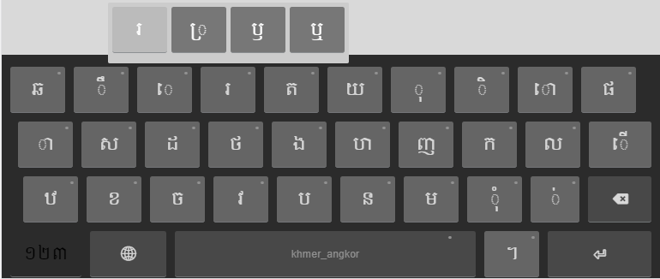

Numeric layout

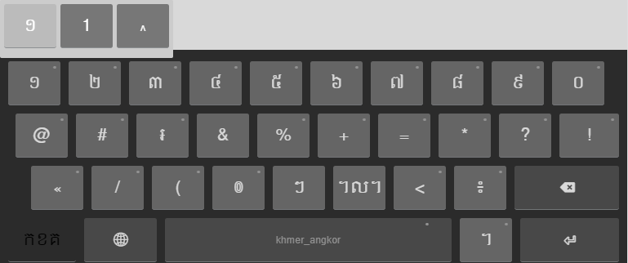

# Khmer Character Categories and Their Keystroke

Each character has a corresponding keystroke under it.

## Consonants

|  |  |  |  |  |
| --- | --- | --- | --- | --- |
| **Consonant** | **Keystroke** |  | **Consonant** | **Keystroke** |
| ក [U+1780] | K | ប [U+1794] | B |
| ខ [U+1781] | X | ផ [U+1795] | P |
| គ [U+1782] | Shift K | ព [U+1796] | Shift B |
| ឃ [U+1783] | Shift X | ភ [U+1797] | Shift P |
| ង [U+1784] | G | ម [U+1798] | M |
| ច [U+1785] | C | យ [U+1799] | Y |
| ឆ [U+1786] | Q | រ [U+179A] | R |
| ជ [U+1787] | Shift C | ល [U+179B] | L |
| ឈ [U+1788] | Shift Q | វ [U+179C] | V |
| ញ [U+1789] | Shift J | ស [U+179F] | S |
| ដ [U+178A] | D | ហ [U+17A0] | H |
| ឋ [U+178B] | Z | ឡ [U+17A1] | L |
| ឌ [U+178C] | Shift D | អ [U+17A2] | Shift G |
| ឍ [U+178D] | Shift Z |  |  |
| ណ [U+178E] | Shift N |  |  |
| ត [U+178F] | T |  |  |
| ថ [U+1790] | F |  |  |
| ទ [U+1791] | Shift T |  |  |
| ធ [U+1792] | Shift F |  |  |
| ន [U+1793] | N |  |  |

## Dependent Vowels

|  |  |  |  |  |
| --- | --- | --- | --- | --- |
| **Dependent Vowel** | **Keystroke** |  | **Dependent Vowel** | **Keystroke** |
| ា [U+17B6] | A | ែ [U+17C2] | Shift E |
| ិ [U+17B7] | I | ៃ [U+17C3] | Shift S |
| ី [U+17B8] | Shift I | ោ [U+17C4] | O |
| ឹ [U+17B9] | W | ៅ [U+17C5] | Shift O |
| ឺ [U+17BA] | Shift W | ុំ [U+17BB][U+17C6] | , |
| ុ [U+17BB] | O | ំ [U+17C6] | Shift M |
| ូ [U+17BC] | Shift O | ាំ [U+17B6][U+17C6] | Shift A |
| ួ [U+17BD] | Shift Y | ះ [U+17C7] | Shift H |
| ើ [U+17BE] | ; | ុះ [U+17BB][U+17C7] | Shift , |
| ឿ [U+17BF] | Shift [ | េះ [U+17C1][U+17C7] | Shift V |
| ៀ [U+17C0] | [ | ោះ [U+17C4][U+17C7] | Shift ; |
| េ [U+17C1] | E | ៈ[1] [U+17C8] | Ctrl Alt ’ |

## Independent Vowels

|  |  |  |  |  |
| --- | --- | --- | --- | --- |
| **Independent Vowel** | **Keystroke** |  | **Independent Vowel** | **Keystroke** |
| ឥ [U+17A5] | - | ឭ [U+17AD] | Shift \ |
| ឦ [U+17A6] | Ctrl Alt I | ឮ [U+17AE] | \ |
| ឧ [U+17A7] | Shift ] | ឯ [U+17AF] | Ctrl Alt E |
| ឩ [U+17A9] | Ctrl Alt [ | ឰ [U+17B0] | Ctrl Alt P |
| ឪ [U+17AA] | ] | ឱ [U+17B1] | Ctrl Alt O |
| ឫ [U+17AB] | Ctrl Alt R | ឲ [U+17B2] | = |
| ឬ [U+17AC] | Shift R | ឳ [U+17B3] | Ctrl Alt ] |

## Diacritics

|  |  |  |  |  |
| --- | --- | --- | --- | --- |
| **Diacritics** | **Keystroke** |  | **Diacritics** | **Keystroke** |
| ៉ [U+17C9] | Shift ’ | ៏ [U+17CF] | Shift 8 |
| ៊ [U+17CA] | / | ័ [U+17D0] | Shift 7 |
| ់ [U+17CB] | ’ | ៎ [U+17CE] | Ctrl Alt = |
| ៌ [U+17CC] | Shift - | ៓ [U+17D3] | Ctrl Alt M |
| ៍ [U+17CD] | Shift 6 | ្ [U+17D2] | J |

## Native Punctuations

|  |  |  |  |  |
| --- | --- | --- | --- | --- |
| **Native Punct.** | **Keystroke** |  | **Native Punct.** | **Keystroke** |
| ។ [U+17D4] | . | ៘ [U+17D8] | Ctrl Alt L |
| ៕ [U+17D5] | Shift . | ៙ [U+17D9] | Ctrl Alt 6 |
| ៖ [U+17D6] | Ctrl Alt ; | ៚ [U+17DA] | Ctrl Alt 7 |
| ៗ [U+17D7] | Shift 2 |  |  |

## Latin Punctuations

|  |  |
| --- | --- |
| **Latin Punct.** | **Keystroke** |
| ! [U+0021] | Shift 1 |
| ? [U+003F] | Shift ? |
| “ [U+0022] | Shift 3 |
| . [U+002E] | Ctrl Alt . |
| , [U+002C] | Ctrl Alt , |
| ; [U+003B] | Ctrl Alt N |
| « [U+00AB] | ` |
| » [U+00BB] | Shift ` |
| - [U+002D] | Ctrl Alt S |
| : [U+003A] | Ctrl Alt G |
| ‘ [U+2018] | Ctrl Alt H |
| ’ [U+2019] | Ctrl Alt J |

## Currencies

|  |  |
| --- | --- |
| ៛ [U+17DB] | Shift 4 |

## Khmer Numerals

|  |  |  |  |  |  |
| --- | --- | --- | --- | --- | --- |
| **Khmer Numeral** | ១ [U+17E1] | ២ [U+17E2] | ៣ [U+17E3] | ៤ [U+17E4] | ៥ [U+17E5] |
| **Keystroke** | 1 | 2 | 3 | 4 | 5 |
| **Khmer Numeral** | ៦  [U+17E6] | ៧  [U+17E7] | ៨  [U+17E8] | ៩  [U+17E9] | ០  [U+17E0] |
| **Keystroke** | 6 | 7 | 8 | 9 | 0 |

## Divination Lore

|  |  |  |  |  |
| --- | --- | --- | --- | --- |
| Divination Lore | Keystroke |  | Divination Lore | Keystroke |
| ៱ [U+17F1] | Ctrl Alt Shift 1 | ៶ [U+17F6] | Ctrl Alt Shift 6 |
| ៲ [U+17F2] | Ctrl Alt Shift 2 | ៷ [U+17F7] | Ctrl Alt Shift 7 |
| ៳ [U+17F3] | Ctrl Alt Shift 3 | ៸ [U+17F8] | Ctrl Alt Shift 8 |
| ៴ [U+17F4] | Ctrl Alt Shift 4 | ៹ [U+17F9] | Ctrl Alt Shift 9 |
| ៵ [U+17F5] | Ctrl Alt Shift 5 | ៰ [U+17F0] | Ctrl Alt Shift 0 |

## Khmer Lunar Dates

|  |  |  |  |  |
| --- | --- | --- | --- | --- |
| Khmer Lunar Date | Keystroke |  | Khmer Lunar Date | Keystroke |
| ᧠ [U+19E0] | Ctrl Alt Shift Q | ᧰ [U+19F0] | Ctrl Alt Shift G |
| ᧡ [U+19E1] | Ctrl Alt Shift W | ᧱ [U+19F1] | Ctrl Alt Shift H |
| ᧢ [U+19E2] | Ctrl Alt Shift E | ᧲ [U+19F2] | Ctrl Alt Shift J |
| ᧣ [U+19E3] | Ctrl Alt Shift R | ᧳ [U+19F3] | Ctrl Alt Shift K |
| ᧤ [U+19E4] | Ctrl Alt Shift T | ᧴ [U+19F4] | Ctrl Alt Shift L |
| ᧥ [U+19E5] | Ctrl Alt Shift Y | ᧵ [U+19F5] | Ctrl Alt Shift ; |
| ᧦ [U+19E6] | Ctrl Alt Shift U |  | ᧶ [U+19F6] | Ctrl Alt Shift ’ |
| ᧧ [U+19E7] | Ctrl Alt Shift I |  | ᧷ [U+19F7] | Ctrl Alt Shift Z |
| ᧨ [U+19E8] | Ctrl Alt Shift O |  | ᧸ [U+19F8] | Ctrl Alt Shift X |
| ᧩ [U+19E9] | Ctrl Alt Shift P |  | ᧹ [U+19F9] | Ctrl Alt Shift C |
| ᧪ [U+19EA] | Ctrl Alt Shift [ |  | ᧺ [U+19FA] | Ctrl Alt Shift V |
| ᧫ [U+19EB] | Ctrl Alt Shift ] |  | ᧻ [U+19FB] | Ctrl Alt Shift B |
| ᧬ [U+19EC] | Ctrl Alt Shift A |  | ᧼ [U+19FC] | Ctrl Alt Shift N |
| ᧭ [U+19ED] | Ctrl Alt Shift S |  | ᧽ [U+19FD] | Ctrl Alt Shift M |
| ᧮ [U+19EE] | Ctrl Alt Shift D |  | ᧾ [U+19FE] | Ctrl Alt Shift , |
| ᧯ [U+19EF] | Ctrl Alt Shift F |  | ᧿ [U+19FF] | Ctrl Alt Shift . |

## Deprecated characters

|  |  |
| --- | --- |
| Deprecated Character | Keystroke |
| ឝ [U+179D] | Ctrl Alt K |
| ឞ [U+179E] | Ctrl Alt B |
| ឨ [U+17A8] | Ctrl Alt T |
| ៜ [U+17DC] | Ctrl Alt Q |
| ៝ [U+17DD] | Ctrl Alt W |
| ៑[2] [U+17D1] | Ctrl Alt 3 |
| ៓ [U+17D3] | Ctrl Alt M |

## Joiners and Spaces

|  |  |  |
| --- | --- | --- |
| **Key name** | **Code Point** | **Keystroke** |
| Zero-width non-joiner | U+200C | Ctrl + Alt + 1 |
| Zero-width joiner | U+200D | Ctrl + Alt + ‘ |
| Zero-width space | U+200B | Spacebar |
| White space | U+0020 | Shift + Spacebar |
| No break space | U+00A0 | Ctrl + Alt + Spacebar |

# Typing in Khmer

Khmer Angkor keyboard adopted the key arrangement from that of NiDA keyboard. More functionalities have been added to it to assist in typing. A well-formed word will be produced regardless of however the user may press. Please note that only issues identified have been covered. To install the keyboard, please follow the instruction [here](https://help.keyman.com/products/desktop/9.0/docs/start_download-install_keyboard.php).

You can simply use Khmer Angkor as you would for any NiDA based keyboard.

## Silent Correction

There are a couple of cases that the keyboard automatically corrects the typos or invalid character sequences.

## Beep

## Special Characters

1. It is actually not a vowel, but it behaves like one. To some, this is a diacritics.
2. Note the different between this character and ៊ [U+17CA].